***Title: Gesture and Motion Recognition***

***A Detailed Study***

**1. Information:**

Motion recognition is a technology that recognizes, processes, and interprets movement or motion patterns. It is a subfield of computer vision and machine learning dealing with the analysis and extraction of information from dynamic actions. Motion recognition systems have applications in human-computer interaction, gesture recognition, surveillance, healthcare, sports analysis, autonomous cars, robotics, and animation and entertainment. They analyze and interpret input from sensors like cameras, depth sensors, accelerometers, and gyroscopes, enabling systems to recognize and respond to different types of motion. The method is utilized in a variety of applications, including gaming, healthcare, sports analysis, autonomous vehicles, robots, and animation.

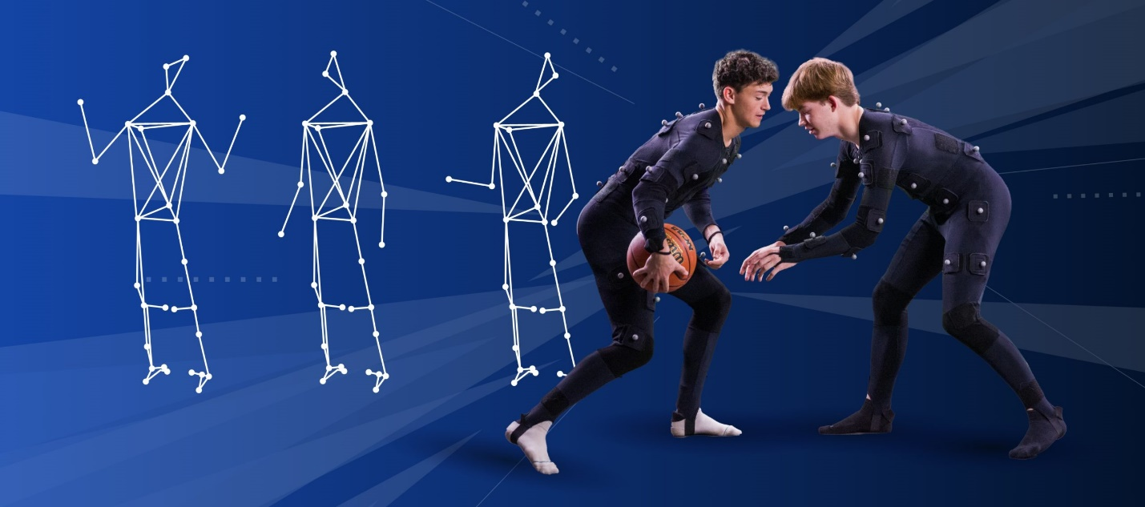

Gesture recognition is an area of understanding and recognizing human gestures as input, including hand movements and finger-written words. These motions are captured and analyzed using cameras or sensors, and the data is interpreted using machine learning algorithms. Gesture recognition has many possible uses including entertainment, gaming, virtual and augmented reality, robotics, sign language recognition, automotive, and healthcare. Sensor-based gesture recognition algorithms monitor and capture human gestures using sensors such as cameras, infrared sensors, and accelerometers. Vision-based gesture recognition systems use cameras or other visual sensors to collect and analyze motions, processing images or videos to recognize the gestures. Users can control devices and interfaces with gestures, facial expressions, or voice commands in these systems.

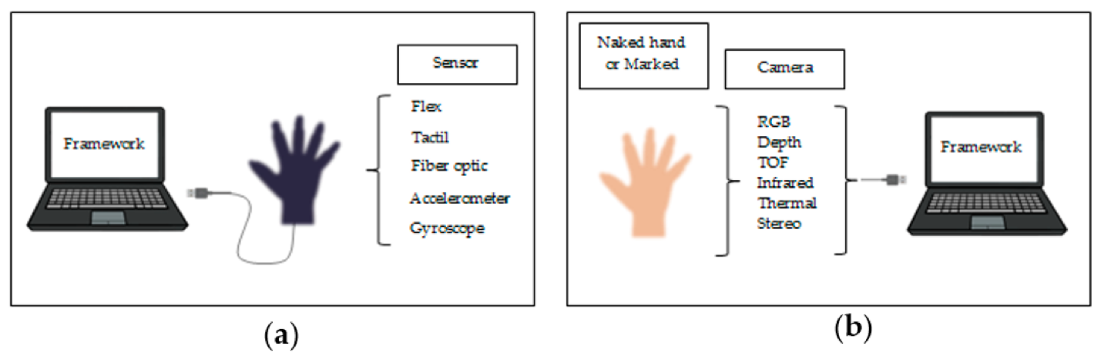

Gesture recognition is a subset of motion recognition. In a broader sense, motion recognition refers to the identification and comprehension of any type of motion, including gestures and other types of movements. Gesture recognition, on the other hand, is only concerned with identifying and comprehending human gestures, which are a subset of motions made by the body, typically the hands or other body parts, that convey specific meanings or instructions. So, while gesture recognition is a type of motion recognition, not every motion recognition includes gesture recognition. Motion detection can include a variety of behaviors, such as walking, jogging, dancing, or general body movements, and it can be utilized in a variety of contexts, such as surveillance, sports analysis, and more.

**2. Literature Survey:**

|  |  |  |  |
| --- | --- | --- | --- |
| Title | Approach used | Accuracy | Limitations |
| Hand Gesture Recognition Based on Computer Vision: A Review of Techniques | It gives us an overview of multiple hand-gesture methods some of which are listed here  1. Data Gloves which can be wearable or direct contact.  2. Computer Vision (CV) does not need to wear any external sensor in this method.  (Color-based, Appearance-based, Deep Learning, Motion-based, etc.) | As multiple approaches were analyzed in this paper, the highest accuracy was established by Deep Learning recognition which was 100% on the training dataset and 99% on the test dataset for the mobile cameras and the webcam 99.9% for the training dataset, and 95.61% for the test dataset. | Fault in interaction systems and difficulty in designing a robust system was addressed by Hand Gesture Recognition. |
| Human motion recognition based on SVM in VR art media interaction environment | For tackling the problem of human motion recognition in multimedia interaction situations in a virtual reality environment, a motion classification and recognition algorithm based on linear decision and support vector machine (SVM) have been proposed in this study. | The average accuracy achieved by using K-means-SVM is 92.15%  and by using LDA-GA-SVM is 97.05%. | The proposed system cannot deal with real-time data, and the system's complexity and scalability have yet to be studied. |
| A Study of Motion Recognition of Objects in Soccer Game | In this study, researchers suggested a method for recognizing object motion from a football game video. It was possible to detect what motion the object was making in real-time by learning its movement using deep learning and, at the same time, recognizing the different motions. This was achieved by adding the tracker for the object to the front of the motion recognition using the input of the actual football game video. | The average accuracy achieved for each motion (Referee, Player, and Assistant Referee) was 79.1%, 71.5%, and 93.7%. | Motion recognition accuracy calls for improvement. |
| Soccer Object Motion Recognition based on 3D Convolutional Neural Networks | In this study, the authors suggested an in-depth method for recognizing motion in football motion pictures. Data collection, preprocessing, 3DCNN machine learning, real-time processing, and plans for future developments and applicability in other sports are all part of the method. The primary purpose was to precisely determine the movements of football objects, specifically officials and ground participants. | Based on the research findings, the field player's, head referee's, and assistant referee's average motion recognition accuracy were 0.449, 0.851, and 0.872, respectively. | While the method appears promising, it has limitations in terms of motion classification accuracy, data quality, real-time processing, applicability to other sports, and model complexity. Addressing these limitations is crucial to the approach's increased application and efficiency in real-life situations. |
| Vision-Based Hand Gesture Recognition | The paper analyses vision-based techniques for hand gesture recognition, focusing on two major classifications: Appearance-Based techniques and 3D Hand Model-Based Approaches. 3D Hand Model-Based Approaches compare input images with projected 2D appearances to calculate hand attributes using high-degree-of-freedom 3D kinematic hand models. Appearance-based approaches use image properties and techniques such as skin color identification, eigenspace, and invariant features to depict the physical appearance of the hand. These techniques are typically used in conjunction with machine learning algorithms such as AdaBoost. | The paper does not specify the accuracy values for the hand gesture recognition algorithms presented. | The drawbacks of the study primarily indicate a need for future research in the field of hand gesture recognition, with a focus on increasing robustness, accuracy, and real-time performance, as well as dealing with challenges connected with real-life circumstances and uncontrolled surroundings. |

**3. Motion Recognition**

Motion recognition, commonly referred to as motion analysis, is a system that captures, processes, and interprets movements or motion patterns. It is a branch of computer vision and machine learning that focuses on comprehending and extracting information from dynamic actions such as human movements, object motions, or any other type of motion.

Motion recognition is an interesting area with multiple uses in a variety of domains. Here is a full breakdown of the applications.

1. **Surveillance and security:** Motion recognition is critical in the surveillance area. It is used by security cameras to detect and monitor activity in restricted areas. Algorithms can distinguish between typical and abnormal behavior and issue alarms as necessary.
2. **Human-Computer Interaction (HCI):** Motion recognition is a popular technique in HCI that allows users to communicate with computers, gadgets, and applications via natural gestures and body motions. Using hand gestures to direct a presentation or body motions in virtual reality environments are two examples.
3. **Robotics:** Motion recognition in robotics allows robots to interact with humans more naturally. Human-robot collaboration is becoming more intuitive as robots can interpret and respond to human gestures and body language.
4. **Gesture Recognition**: This is a subset of motion recognition that focuses on recognizing and comprehending hand and body gestures. It is utilized in devices such as gaming consoles (e.g., Microsoft Kinect) to interpret user gestures and control media playback.
5. **Motion Recognition in Animation and Entertainment**: Motion recognition is used in the entertainment business to capture motion. It records the actions of actors and converts them into digital characters or monsters for use in movies, video games, and virtual settings.
6. **Motion Recognition in Healthcare and Physical Therapy:** Motion recognition is a useful tool in physical therapy and rehabilitation. It monitors a patient's movements throughout workouts and offers real-time feedback, ensuring that the exercises are performed correctly and securely.
7. **Autonomous Vehicles:** Self-driving cars use motion recognition to detect and track pedestrians, bicycles, and other vehicles' motions. This data is critical for self-driving cars to make safe and informed decisions on the road.
8. **Sports Analysis:** Motion recognition is used in sports to analyze athletes' motions. It can assist coaches and athletes in better understanding their performance, identifying areas for improvement, and avoiding injury. In this regard, motion capture technology is frequently used.

**The technology behind Motion Recognition**

1. **Sensors:** Cameras, depth sensors (e.g., Microsoft Kinect), accelerometers, gyroscopes, and even radar are used to gather motion data. These sensors collect information about movement in the environment.
2. **Data Preprocessing:** To clean and prepare raw sensor data for analysis, it is often necessary to preprocess it. This could include noise reduction, calibration, and data alignment from numerous sensors.
3. **Feature Extraction:** Feature extraction is the process of identifying relevant patterns and attributes in motion data. This stage simplifies and prepares the data for analysis.
4. **Machine Learning and Computer Vision**: To analyze and interpret motion data, machine learning algorithms, including deep learning models, are used. Computer vision algorithms extract information from images or video streams, enabling for movement recognition and tracking.
5. **Pattern Recognition:** Pattern recognition algorithms are used to categorize and comprehend motion patterns that have been detected. These algorithms can distinguish between many sorts of movements, whether basic gestures or sophisticated actions.
6. **Response and Control:** The motion recognition system activates specific responses or controls in various applications. Recognized gestures, for example, can control in-game actions in a virtual reality system.

In a nutshell, motion recognition technology is crucial to many applications because it excels in capturing, analyzing, and comprehending a wide range of motion types. Its ability to comprehend human motions, gestures, and environmental changes has enabled breakthrough advances in sectors such as gaming, healthcare, security, and transportation.

**4. Gesture Recognition**

Gesture recognition is a subset of motion recognition that focuses on human gesture recognition and interpretation. These gestures are a subset of the greater category of bodily movements, and they are usually intentional acts performed by various portions of the body, such as the hands, arms, or face, to transmit certain meanings, directives, or feelings. Gestures, unlike random movements, serve a goal and are frequently utilized as a form of symbolic or linguistic expression. A simple wave of the hand, for example, can indicate a greeting, a thumbs-up gesture can convey approval, and sophisticated hand movements in sign language can represent distinct letters or words. The fundamental distinction here is that gesture recognition is concerned with these intentional, meaningful movements and is an important technique in applications such as sign language translation, human-computer interface, and others.

**4.1 Gesture Recognition and Detection Technologies**

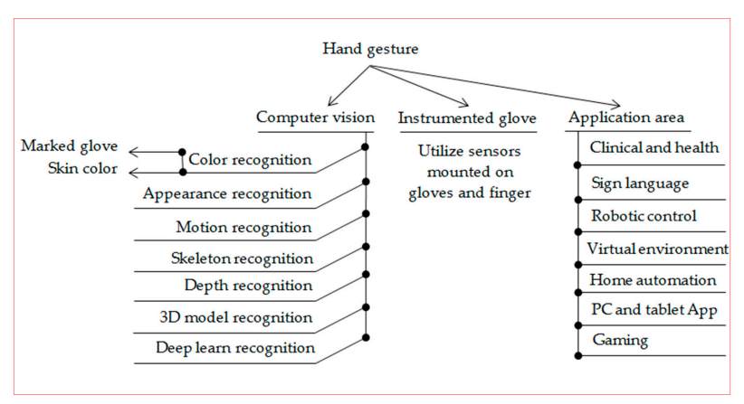

**Sensor-Based Gesture Recognition:** Sensor-based gesture recognition uses various sensors like cameras, infrared sensors, and accelerometers to understand human gestures. These sensors are put in the right places to watch and record how a person's body or limbs move. For instance, cameras can track hand movements, and accelerometers can sense changes in how you hold something. A special computer program looks at the data from these sensors and tries to figure out what gesture you're making. It looks at things like the shape, speed, and direction of your movements. This kind of system is super handy when you need very exact info about how someone's moving. Think of it like when you're in a virtual reality game, and you want your character's every move to match yours.

**Vision-Based Gesture Recognition:** On the other hand, vision-based gesture recognition systems rely on cameras and similar tools to see and understand gestures. You often see these systems in things like game consoles and when translating sign language. Cameras take pictures or videos of the gestures you make. Then, some smart computer stuff happens, and the system can figure out what you're doing. A regular vision-based system has a few important parts: A camera or sensor that captures your gestures. It gets the data ready by fixing up the pictures and getting rid of any fuzziness. There's a part that picks out the important bits from the data, like the main points or shapes in the pictures or video. Then, there's a piece that uses fancy math to say, "Hey, that's a thumbs-up!" or "Look, an open hand!" Finally, it takes what it knows and turns it into something that makes sense, like making a thumbs-up mean "like" in a computer program.

Both sensor-based and vision-based systems have their strengths. Sensor-based ones are awesome when you need to know exactly how someone's moving, like in virtual reality. Vision-based systems are great when you need to see and understand gestures, like when you're gaming or using sign language.

**1. Human-Computer Interaction:** The utilization of gesture recognition technology enhances human interaction with computers, smartphones, and similar devices. Instead of relying on conventional methods like keyboards or touchscreens, users can control these devices effortlessly using hand gestures, such as swiping for scrolling, tapping to select, or pinching to zoom. This approach provides a more natural, touch-free user experience.

**2. Gaming**: In the realm of gaming, gesture recognition introduces an extra layer of immersion and engagement. Gamers can manipulate characters and objects in video games through hand and body movements. For instance, motion-controlled gaming consoles enable players to swing their arms like a tennis racket in a tennis game or dance to guide an on-screen avatar. This technology blurs the line between the virtual and physical worlds, rendering gaming more dynamic.

**3. Virtual and Augmented Reality:** Gesture recognition is an integral part of virtual and augmented reality encounters. Users can interact with the simulated environments by making gestures. For example, in a virtual reality game, users can reach out and grasp virtual objects thanks to gesture recognition. This capability empowers users to direct and manipulate items within these digital realms, resulting in a more immersive and captivating experience.

**4. Robotics**: In the field of robotics, gesture recognition empowers users to communicate with robots via gestures. Robots can be programmed to interpret and respond to specific gestures, allowing them to execute tasks in response to user cues. For instance, a robot could recognize a "stop" gesture to halt its movement or interpret a "come here" gesture as an invitation to approach the user.

**5. Sign Language Recognition**: Gesture recognition finds a profoundly meaningful application in sign language. This technology can identify and transform sign language gestures into spoken or written language. This breakthrough has profound implications, particularly for individuals who are deaf or hard of hearing, as it facilitates communication with those who may not be familiar with sign language. It effectively bridges the gap between distinct forms of language and promotes more inclusive communication.

**6. Automotive:** Gesture recognition can be integrated into vehicles to manage various functions. For example, a simple gesture can adjust the radio volume, while another gesture might alter air conditioning settings, and so forth. This hands-free interaction is not only convenient but also enhances safety by enabling drivers to keep their hands on the wheel while making adjustments.

**7. Healthcare**: Gesture recognition technology serves valuable roles in the healthcare sector, particularly in the rehabilitation of patients with physical disabilities. It assists in tracking and evaluating patients' movements and exercises. By providing real-time feedback, it aids both patients and healthcare providers in monitoring progress and ensuring exercises are performed correctly, thus contributing to the recovery and rehabilitation process.

In all these scenarios, gesture recognition technology simplifies and enhances interactions between humans and a variety of systems, devices, and environments. It delivers convenience, interactivity, and accessibility.

**5. Results and Conclusion**

We investigated the domains of gesture and motion recognition in this study, looking at their applications, technologies, and significance in numerous sectors.In conclusion, the fields of gesture and motion recognition have brought about significant improvements in many aspects of daily existence. They've fundamentally transformed our interactions with computers, gaming experiences, travels into virtual and augmented realities, collaborations with robotics, communication facilitation, empowering of vehicle controls, and supply of critical support in healthcare and sports analysis. Nonetheless, there are still challenges to solve, such as the need for real-time performance, adaptability in uncertain environments, and increased precision. Conquering these hurdles is critical to ensuring the continued growth and success of these technologies. With continued advances in research and development in the fields of gesture and motion recognition, we should expect even more profound implications on technology and human-machine interactions. These advancements will help to raise the bar even higher.

**7. Code**

Here’s an example of Gesture and Motion Detection implementation and application areas

Following is the Flow System Architecture for Real-Time Hand Gesture Recognition



Video Input

(Real-Time Web Cam data)

Hand Landmark Analysis

Image Preprocessing

Hand Detection

&Tracking



Continuous Loop

Gesture Feedback

Gesture Recognition

Video Display

This system for real-time gesture identification begins by capturing video input from a camera, then detects and tracks hand landmarks using the MediaPipe library. Following that, it examines hand gestures based on the locations and movements of these landmarks, allowing it to identify actions such as "STOP," "FORWARD," "BACKWARD," "LEFT," "RIGHT," "LIKE," and "DISLIKE." The technology provides real-time feedback by superimposing text labels onto video frames and continually works to respond to user actions. Furthermore, it has the capacity to manage numerous operations inside a computer system or to be easily incorporated into various applications, exhibiting its versatility for interactive gesture-driven control.

**Control Mechanisms:** The capabilities of the system may be increased to manage a wide range of operations within a computer system. Notably, detected gestures have the ability to activate specific operations or interactions, such as user interface navigation, presentation control, or the transmission of instructions to networked devices. Furthermore, the system allows for the integration of external systems or applications, allowing for gesture-driven command over a variety of areas. It might, for example, be coupled to a video player, a robotic system, or home automation apps.

Github link for code:

**8. References**

<https://www.mdpi.com/2313-433X/6/8/73>

Hand Gesture Recognition Based on Computer Vision: A Review of Techniques

<https://hcis-journal.springeropen.com/articles/10.1186/s13673-019-0203-8>

Human motion recognition based on SVM in VR art media interaction environment

<https://ieeexplore.ieee.org/document/7890223>

A Study of Motion Recognition of Objects in Soccer Game

<https://www.researchgate.net/publication/327893375_Soccer_object_motion_recognition_based_on_3D_convolutional_neural_networks>

Soccer Object Motion Recognition based on 3D Convolutional Neural Networks

<https://www.academia.edu/65711329/Vision_Based_Hand_Gesture_Recognition?from_sitemaps=true&version=2>

Vision-Based Hand gesture recognition

<https://www.google.com/url?sa=i&url=https%3A%2F%2Fwww.motionanalysis.com%2Fanimation%2Fkeyframe-animation-or-motion-capture-which-should-you-choose%2F&psig=AOvVaw18dqssfzxwlSlwl3H7NKri&ust=1698719453206000&source=images&cd=vfe&opi=89978449&ved=0CBIQjRxqFwoTCNCI357dnIIDFQAAAAAdAAAAABAh>

<https://www.google.com/url?sa=i&url=https%3A%2F%2Fwww.mdpi.com%2F2313-433X%2F6%2F8%2F73&psig=AOvVaw0aLtTie1bvvEkeftI-4XgV&ust=1698719668264000&source=images&cd=vfe&opi=89978449&ved=0CBIQjRxqFwoTCODonoXenIIDFQAAAAAdAAAAABAE>